Pupil Premium at Tenbury High Ormiston Academy
2020-2021

Rationale:

Equity Vs Equality

“Equity is not the same as equality. It means schools doing more for some children than others in order to create a more level playing field. Recognising that some children have a very narrow experience outside school and providing them with additional opportunities is an important step in ensuring that they can make the most of their educational opportunities.” Sir John Dunford

The difference between equality and equity must be emphasised. Although both promote fairness, equality achieves this through treating everyone the same regardless of need, while equity achieves this through treating people differently dependent on need. However, this different treatment may be the key to reaching equality.
Fairness through equality would mean giving all students the same level of support. However, those who need more support beyond this initial level to succeed would therefore not have equal opportunities to those who do not.

Our context

Year 7 has 17 Pupil premium pupils (18.8%)
Year 8 has 20 Pupil premium pupils (21.7%)
Year 9 has 23 Pupil premium pupils (26.4%)
Year 10 has 19 Pupil premium pupils (23.1%)
Year 11 has 9 Pupil premium pupils (13.8%)
Overall, we have 21.2% pupil premium. Nationally, 27.1% of pupils are eligible for deprivation pupil premium, in Worcestershire it is 21.4%.

The school post-code area of WR15 8XA has a deprivation decile of 6. From the 2015 data, Worcestershire has seen a decrease in deprivation.
Our school gains pupils from Worcestershire, Shropshire and Herefordshire, whose deprivation profiles are:

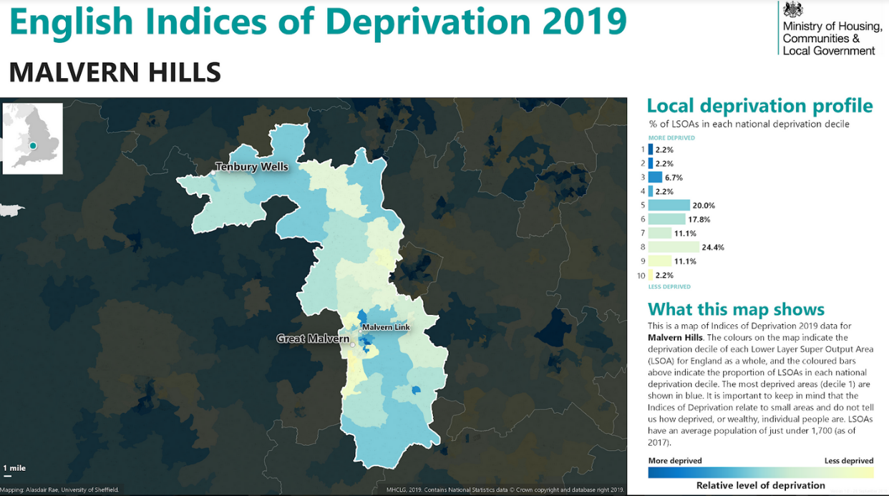

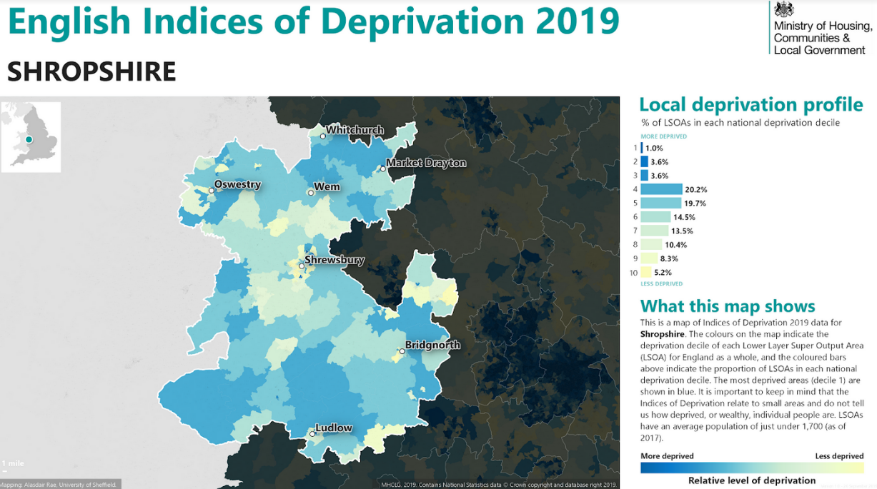

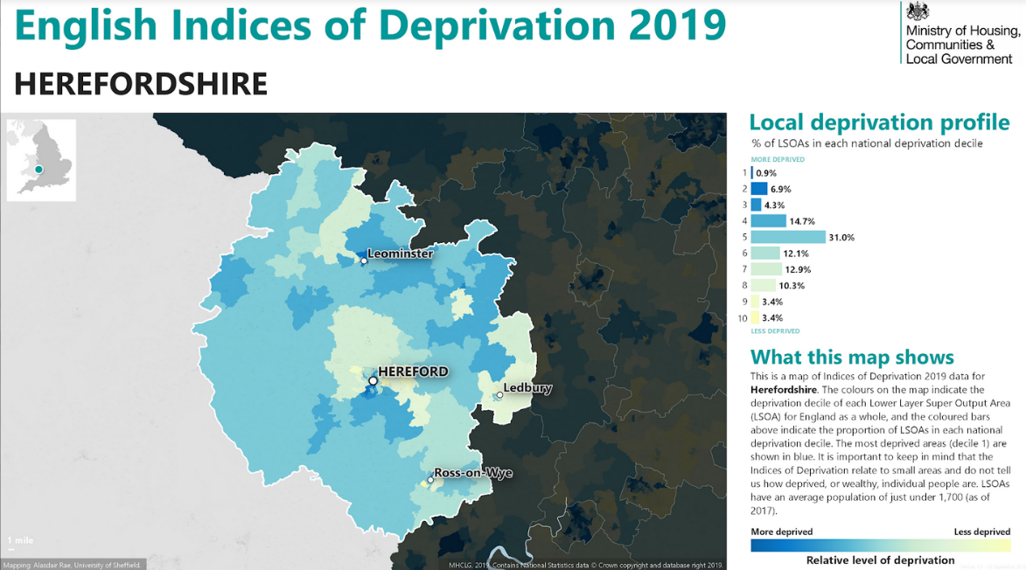

Pupil premium learners did not engage in home learning as much as non-pupil premium learners. Therefore, widening the gap in attainment between PP and non-PP pupils.

Access to mentoring, counselling and school nurse and any other external agencies
Extra Transition in the summer through the 6-7 project
Additional teaching group, academic mentoring
Close monitoring of attendance: Daily attendance calls for every PP learner. Welcome back chat after each prolonged absence
Specific CPD for quality first teaching and differentiation including bespoke coaching
Pupil premium pupils’ work is marked first by staff
Involvement of family support worker for any PP pupil whose attendance falls below 93%
Making school relevant e.g. careers advice and raising post 16 aspirations

£100 personal spend and provision of subject specific revision guides/work books/catering ingredients
PASS testing and intervention
Buddy Pupils
in lessons
Pupil progress meetings for year 10 and 11 after each DC will focus on PP (venn and all subjects)pupils
Resources printed if required

Supporting Pupil Premium Learners in the Classroom

In Every Lesson
- Meet and greet, get to know them personally as well as academically, check in with them after transitions e.g. weekends, break times, periods of absence
- Check they understand the learning before they start and during the lesson
- Ensure they know what they are aiming for – what does a good one look like? How will they know they have met the learning objective?
- Use a range of questioning to support and challenge – use cold calling and additional waiting time to increase their participation
- Offer verbal feedback throughout the lesson
- Check who they are sitting next to – is it someone who can give them different ideas? Model good spoken English? Buddy pupil premium learners with someone who can support them
- Include paired and group work – provide ground rules for this and make sure pp are actively involved
- Lesson resources are to be printed if required

In English Lessons
- Send texts home over the weekend before you will be studying them in class
- Pre-teach vocabulary that will be covered in class that week
- Use visuals to demonstrate meaning of vocabulary, scenes and characters
- Encourage children to speak their sentences out loud before writing them. Extend their ideas with conjunctions and model phrases that they could use. Use cubes to count the words in the sentence. Use recording devices so they can play back what they have written.
- Provide word banks, sentence starters and other words or phrases that match the genre – model how to use these so they don’t just become ‘another thing’ on the desk

In Maths Lessons
- Provide times table squares, 100 squares, number lines, bead strings etc as appropriate
- Teach children when the above could be used so they become more independent
- Provide partly completed calculations
- Provide modelled examples for children to copy the method
- Use concrete resources to secure a new concept
- Revise previous learning frequently to secure it in the memory
- Provide speaking frames so children can reason and explain their answers clearly

Interventions
- For a set period of weeks not indefinitely
- Specifically targeted at gaps
- Monitored for effectiveness – if it’s not helping to close the gaps then try a different approach
- Pre-teaching concepts and vocabulary

